**Guide to the typical arthropod: The freshwater shrimp.**

We will be using as the grass shrimp as our model for open circulation. This species is relatively large and transparent, so that most of its organs can be seen using the stereoscope. You may try feeding it some fish food. Just use a pinch so water does not become contaminated. For a side view, try giving it a small rock or piece of vegetation to hang on to. Often you can tilt the vegetation for a better view of side view of some important organs such as the bill.

1. External anatomy. Try to identify the different segments of the body, cephalothorax (carapace), and abdomen. Try to count the number of abdominal segments, legs, and walking legs. Do they match the number in the picture below, which is a diagram of a large commercial shrimp cultivated for food? RECORD YOUR OBSERVATIONS IN YOUR JOURNAL

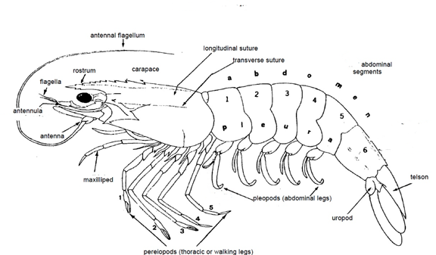

2. Internal anatomy: Below is a diagram of a female crayfish.

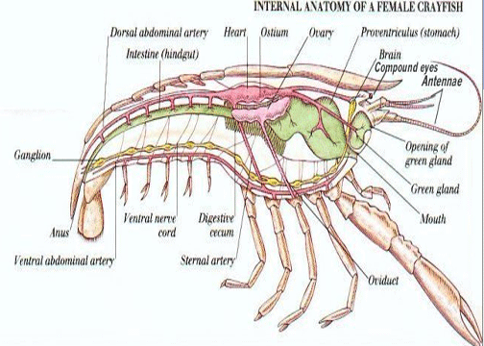

The reproductive organs of the male appear as smaller but similar sac like structures. You will probably be able to easily distinguish the heart, gills (need side view), stomach and intestine. Feed you animal some colored fish food and if it is cooperative, you should be able to trace the movement of the food down the digestive track. Can you describe how the mouthparts move while the shrimp is feeding?

|  |  |
| --- | --- |
|  | Gills are located just below the heart. |

**3. Open circulatory system.**

Can you trace the flow of hemolymph out of the heart into the major arteries? RECORD YOUR OBSERVATIONS IN YOUR JOURNAL. Below are some diagrams to help you.

The first is of a lobster. Crayfish and shrimp are smaller, and may not have visible ventral arteries. It is a very good diagram of the relationship of the gills to the major vessels and heart.

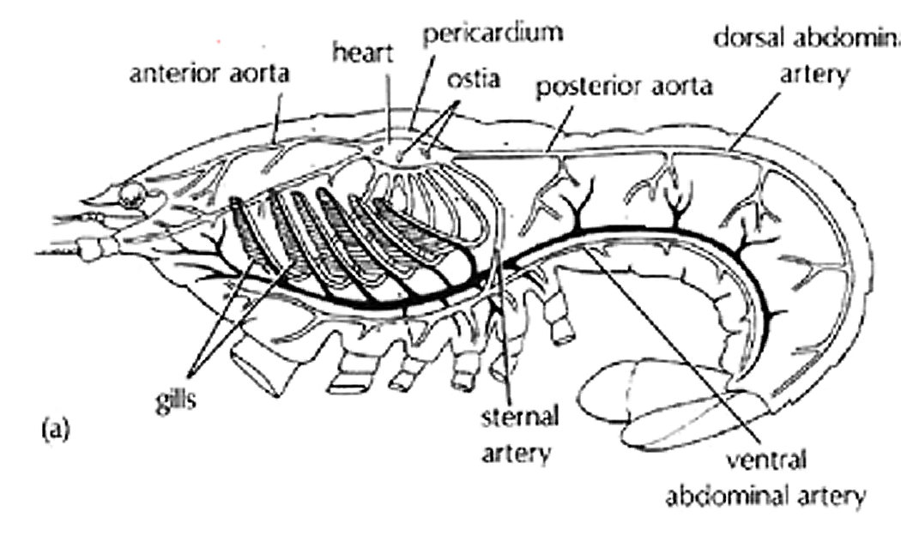

Diagram of heart showing relative placement of ostia in shrimp and crayfish.

|  |  |
| --- | --- |
|  | You should try following the anterior median artery since it will not be as obscured by other organs as the dorsal artery. |
| You probably will not be able to see ostia in these small shrimp. | |